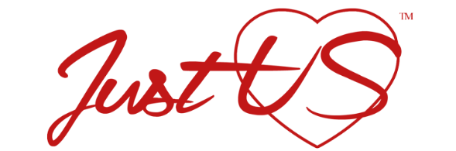

Location RELEASE
SERIES / PROGRAM TITLE: Sit Down with StacyK: YouTUBE channel / Stacy Snapp-Killian (aka) StacyK. You are agreeing to allow your property to be filmed for a documentary type video containing the subject matter of sexual abuse and/or sexual suppression™. All videos are for the purpose of education and inspiration.

PRODUCTION DATE: ____________________________________________

Permission is hereby granted to The Justus Love Corporation to use the property located at
[_______________________________________]
for the purpose of photographing and recording scenes for the above program produced by
Stacy Snapp-Killian.
Permission includes the right to bring personnel equipment onto the property and to remove them after
completion of the work.
The permission herein granted shall include the right, but not the obligation, to
photograph the actual name connected with the premises and to use such person(s) in the program(s).

The undersigned hereby gives to The Justus Love Corporation, its assigns, agents, licensees, affiliates, clients, principals, and
representatives the absolute right and permission to copyright, use, exhibit, display, print, reproduce, televise, broadcast and distribute, for any lawful purpose, in whole or in part, through any means without limitation, any scenes containing the above described premises and person(s), all without inspection or further consent or approval by the undersigned of the finished product or of the use to which it may be applied.

We hereby agrees to hold the undersigned harmless of and free from any and all liability and loss
which The Justus Love Corporation, and/or its agents, may suffer for any reason, except that directly caused by the negligent
acts or deliberate misconduct of the owner of the premises or its agents.

The undersigned hereby warrants and represents that the undersigned has full right and authority to solely enter into
this agreement concerning the above described premises, and that the undersigned hereby indemnifies and holds
The Justus Love Corporation, and/or its agents, harmless from and against any and all loss, liability, costs, damages or claims
of any nature arising from, growing out of, or concerning the use of the above described premises except those
directly caused by the negligent acts or deliberate misconduct of The Justus Love Corporation, or its/his/her agents.

By (Property Owner/Manager):________________________________________________
Signature of Authorized Property Representative
Date: ______________________________

By Person interviewing with Stacy Snapp-Killian for YouTube Channel: _____________________________
Date: _______________________________________

Filmmaker/Film Location Manager: Stacy Snapp-Killian Date: _______________________

