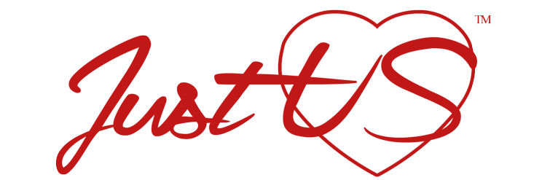
RELEASE AGREEMENT

Whereas, ______________ (the "Producer") is engaged in a project (the "Documentary"), known as “Sit Down with StacyK” to film his or her story of sexual abuse inspiration.

Whereas, I, the undersigned, have agreed to appear in the Documentary, and to sit down with StacyK for a one-on-one interview type setting.

I understand that my voice, name, and image will be recorded by various mechanical and electrical means of all descriptions such recordings, any piece thereof, the contents therein and all reproductions thereof, along with the utilization of my name, shall be collectively referred to herein as the released subject matter; sexual abuse and/or sexual suppression.

Therefore, I will receive $1.00, in exchange for my story and receipt of which is hereby acknowledged and whose sufficiency as consideration I affirm, I hereby freely and without restraint consent to and give unto the Producer and its agents or assigns or anyone authorized by the Producer, (collectively referred to herein as the "Releases") the unrestrained right in perpetuity to own, utilize, or alter the Released Subject Matter, in any manner the Releases may see fit and for any purpose whatsoever, all of the foregoing to be without limitation of any kind. Without limiting the generality of the foregoing, I hereby authorize the Releases and grant unto them the unrestrained rights to utilize the Released Subject Matter in connection with the Documentary’s advertising, publicity, public displays, and exhibitions. I hereby stipulate that the Released Subject Matter is the property of the Producer to do with as it will.

I hereby waive to the fullest extent that I may lawfully do so, any causes of action in law or equity I may have or may hereafter acquire against the Releases or any of them for libel, slander, invasion of privacy, copyright or trademark violation, right of publicity, or false light arising out of or in connection with the utilization by the Releases or another of the Released Subject Matter.

It is my intention that the above mentioned consideration represents the sole compensation that I am entitled to receive in connection with any and all usages of the Released Subject Matter. I expressly stipulate that the Releases may utilize the Released Subject Matter or not as they choose in their sole discretion without affecting the validity of this Release. This Release shall be governed by the laws of the State of Texas.

I hereby certify that I am over the age of eighteen, and that I have read, understood, and agreed to the foregoing.

Print Name ____________________________________________

Signature ____________________________________________ Date: _______________

Address: ____________________________________________

City/State/Zip: ____________________________________________

Phone Number (with area code): Day _____________________ Evening __________________

